Wednesday 16th June, 2021
Dear Parents and Carers
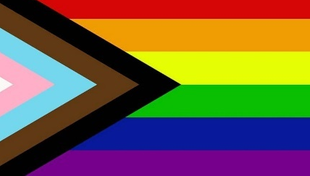
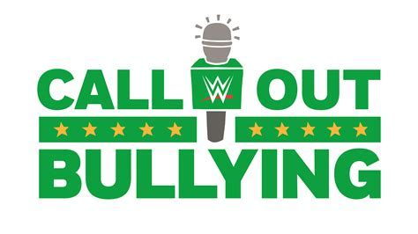
NEXT WEEK is SCHOOL DIVERSITY WEEK
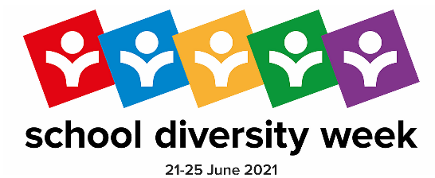
As you will know from our Twitter and Facebook accounts, this month we are celebrating ‘Pride’ and next week we are fully involved in School Diversity Week; this annual week is all about empowering school staff and pupils across the UK to tackle homophobic, biphobic, and transphobic bullying by organising activities that celebrate LGBT+ equality in education.
In 2020, schools and colleges representing 1.9 million young people signed up to take part in School Diversity Week, demonstrating to their pupils that being LGBT+ is something to be celebrated.
All pupils will take part in age-appropriate activities, including hearing stories being read, watching presentations, taking part in class or year group assemblies and answering questions such as ‘What makes you unique?’, ‘What makes you, you?’, ‘What are your hopes and dreams?’, ‘Who/what makes you proud?’ etc.
Next Friday, we will also be taking part in Rainbow Friday – we would like to invite all members of our school community to wear a colour – or several colours – of the Progress Flag (the updated version of the Pride flag above). You will notice this now includes black and brown – to represent people of colour; also baby-blue, pink and white – to represent the trans flag.
We will then share photos (with already-held permissions) of our Rainbow Friday outfits on social media!
We will be using #SchoolDiversityWeek and tag @JustLikeUsUK on Twitter or Instagram to show our support for LGBT+ young people, especially those in our school community and families.
Attached to this letter are some resources to support you at home.

Kind regards,
Alistair Kiff Simon Wood
Deputy Head – Inclusion Executive Head

