Homophobia
has no place in our school

Biphobia has
no place in our school

Transphobia
has no place in our school

There are no
outsiders in our school

Be proud of
who you are

LGBT+
equality is everyone's issue

Being gay
won't get in the way of having an awesome life

Being
non-binary won't get in the way of having an awesome life

Being bisexual
won't get in the way of having an awesome life

Being trans
won't get in the way of having an awesome life

Being a lesbian
won't get in the way of having an awesome life

There isn't
one way to be gay

There isn't
one way to be straight

There isn't
one way to be trans

There isn't
one way to be bisexual

There isn't
one way to be non-binary

There isn't
one way to be a lesbian

There isn't
one way to be LGBT+

There isn't
one way to be a girl

There isn't
one way to be a boy

Life would
be boring if we were all the same

Be yourself,
everyone else is already taken

It's illegal
to discriminate against LGBT+ people

Being gay
is something to be celebrated

Being a lesbian
is something to be
celebrated

Being bisexual
is something to be celebrated

Being trans
is something to be celebrated

Being
non-binary is something to be celebrated

Being LGBT+
is something to be celebrated

No subjects
are just for girls

No subjects
are just for boys

LGBT+ secondary
school pupils are twice as likely to feel lonely on a daily basis and more than twice as likely to worry about their mental health
on a daily basis

Together we can change that

1 in 4 LGBT+ secondary
school pupils people are experiencing daily tensions in the place they are living

Together we can change that

7 in 10 LGBT+
secondary school pupils say their mental health has worsened since the pandemic began

Together we can change that

Almost half of
secondary school pupils in the UK say they have received little to no positive messaging at school about being LGBT+ in the past year

Together we can change that

Rina Sawayama was
nominated for the BRITs Rising Star Award

and she’s pansexual

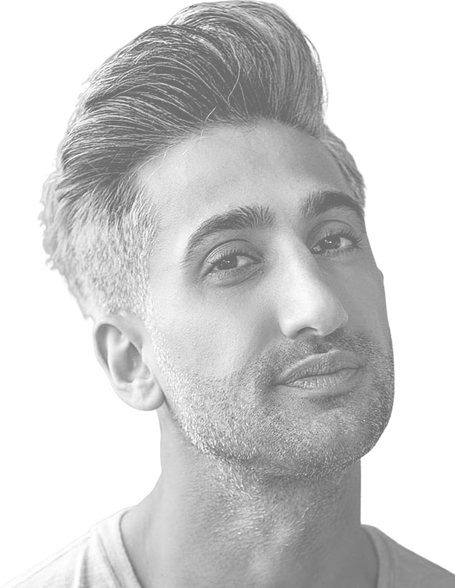

Tan France stars
in Queer Eye and Next in Fashion

and he’s gay

Nikki De Jager
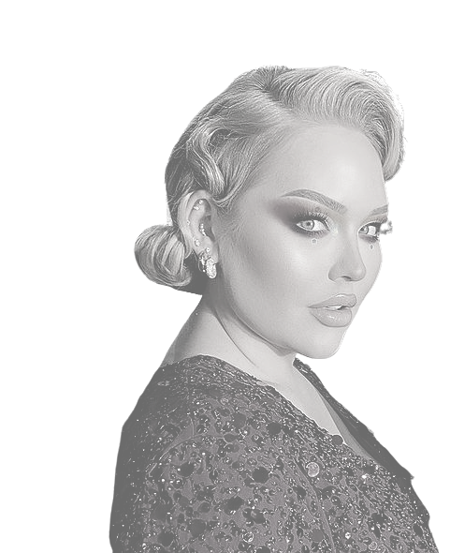
has over 13 million subscribers on YouTube

and she’s trans

Sam Smith has
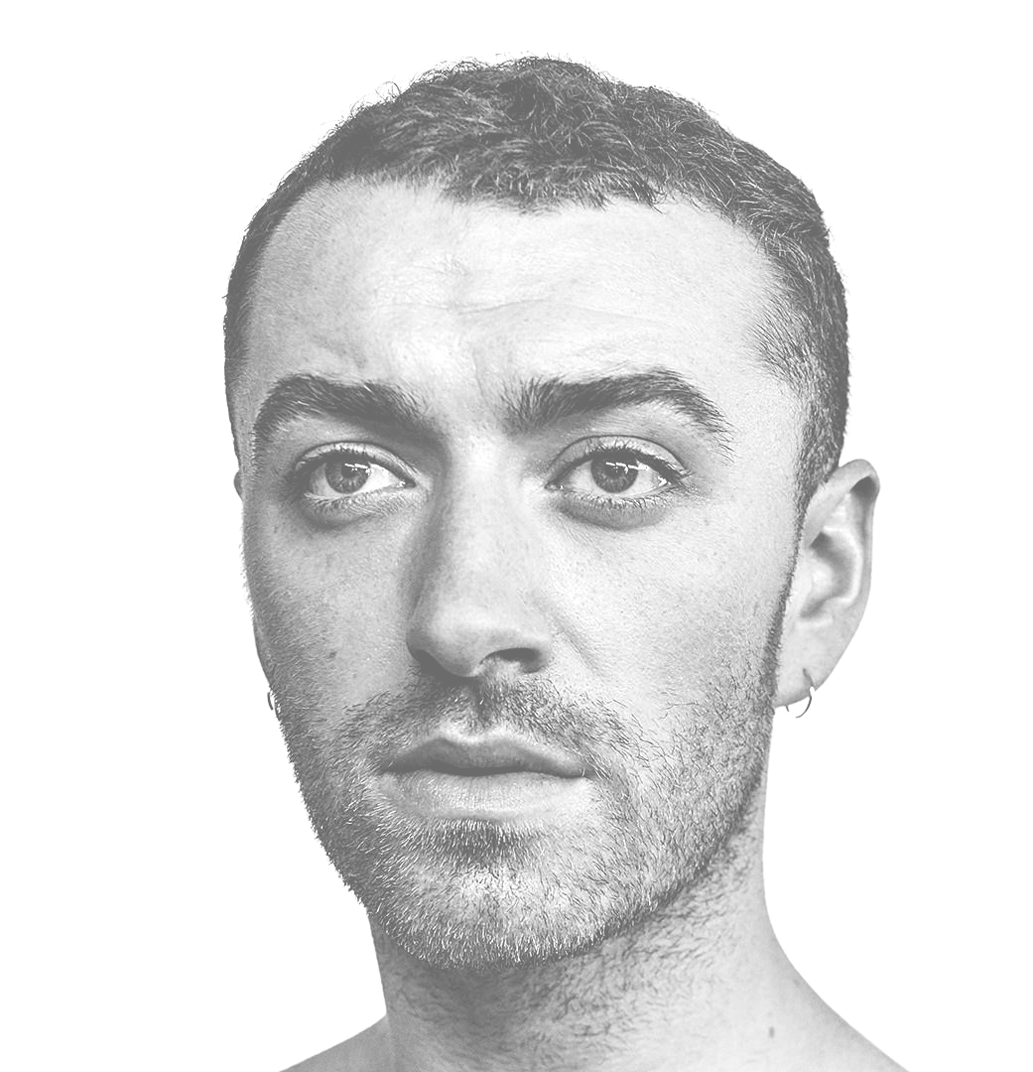won four Grammy Awards

they're non-binary

and

Chella Man stars in
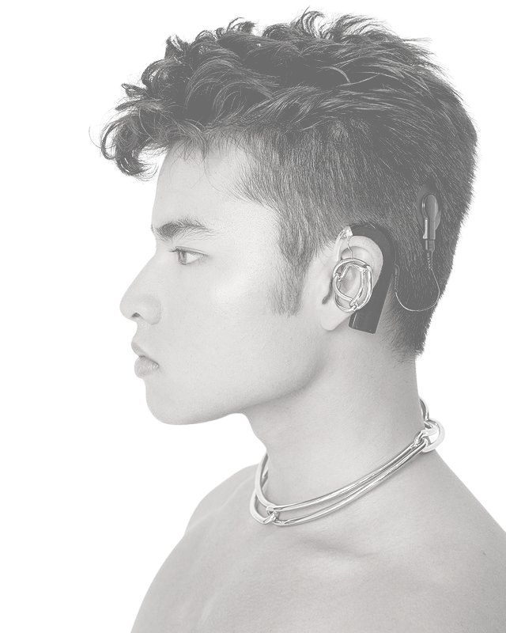
the DC Universe series, Titans

and he's trans

Nicky Bandini
is a sports writer and broadcaster

and she's trans

Mhairi Black is
a Scottish MP

and she's a lesbian

Tim Cook is the CEO
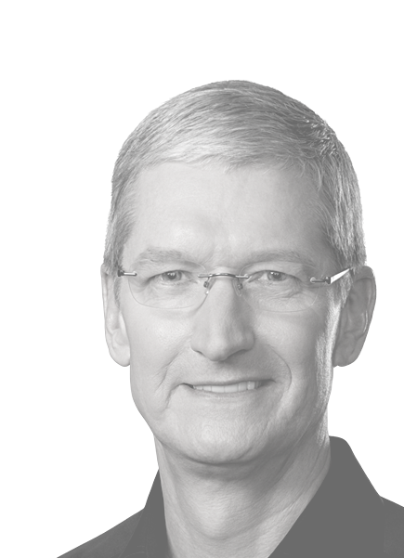
of Apple, the most valuable company in the world

and he's gay

Frank Ocean is a
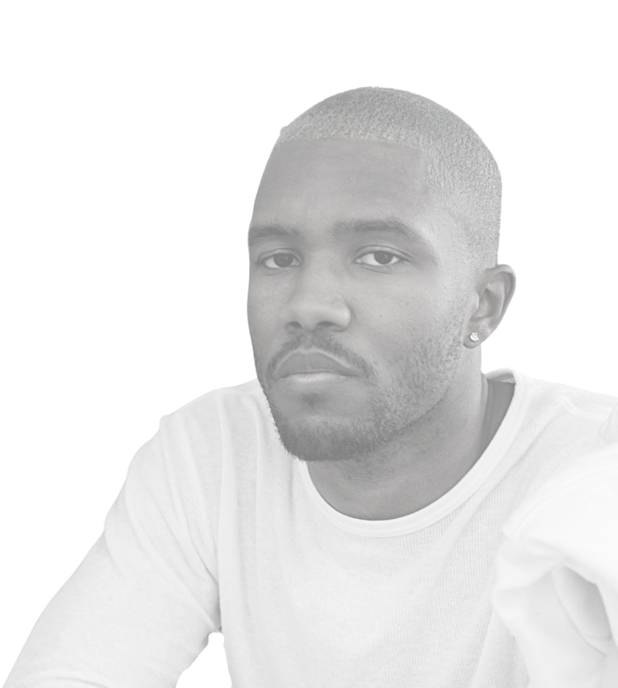
Grammy-winning artist

and he's bisexual

Laverne Cox starred
in Orange is the New Black

and she's trans

Ben Hunte is a BBC
news correspondent

and he's gay

Elliot Page starred in
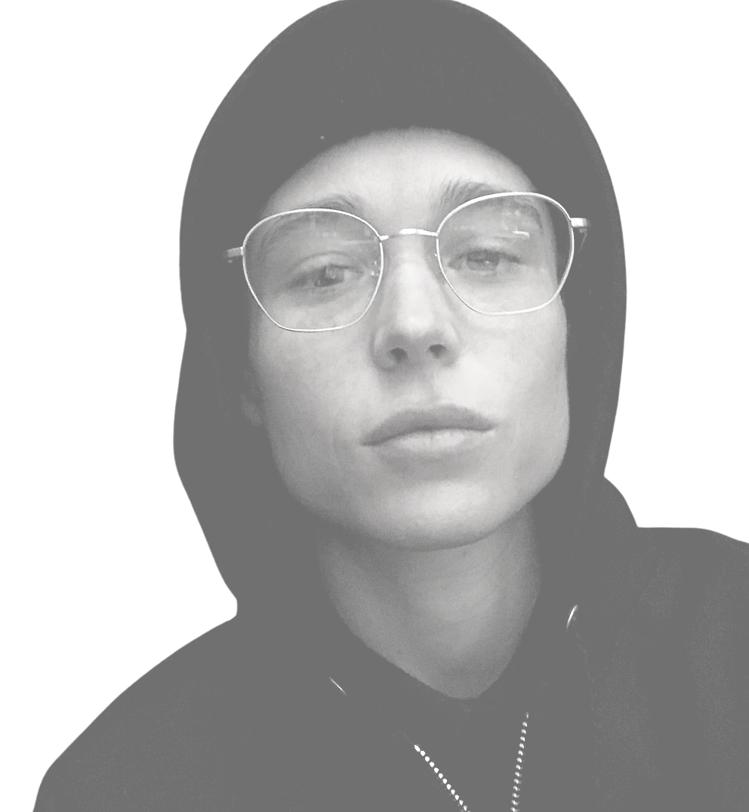
the X-Men films

and he's trans

Fara Williams plays
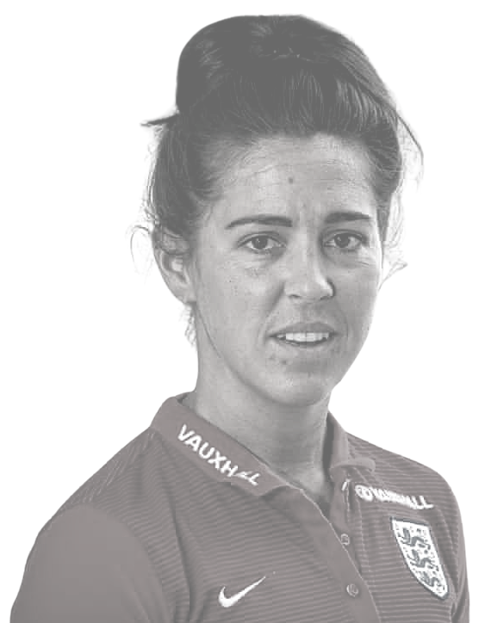
football for England

and she's a lesbian

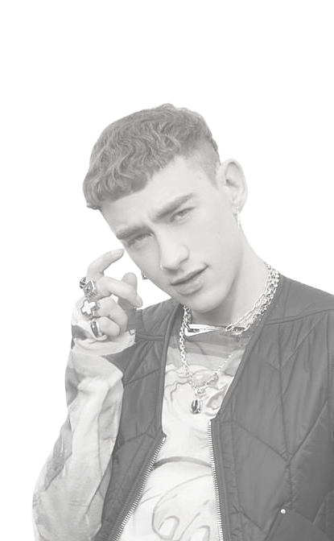

Olly Alexander is a
successful pop artist and actor

and he's gay

Jonathan Bailey
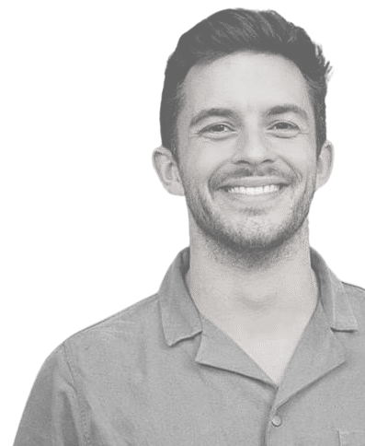
stars in Netflix's most watched show ever

and he's gay

Levi Davis plays
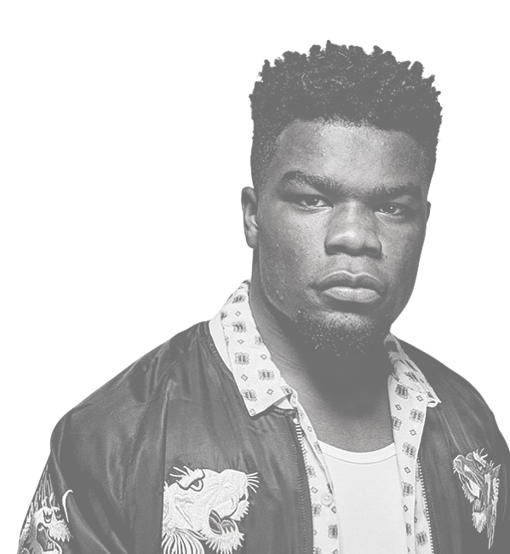
Premiership Rugby for England

and he's bisexual

Joe Lycett is a
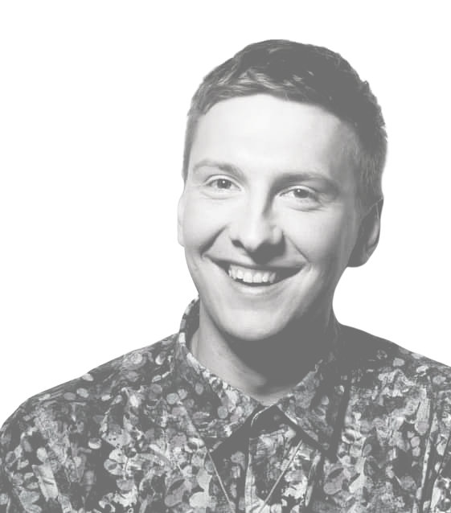
hugely successful comedian

and he's pansexual

Stephanie Beatriz
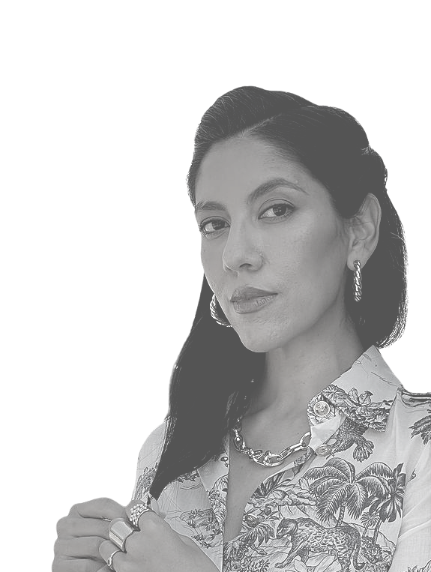
stars in Brooklyn Nine-Nine

and she's bisexual

