Curriculum Overview for Spring Year 6
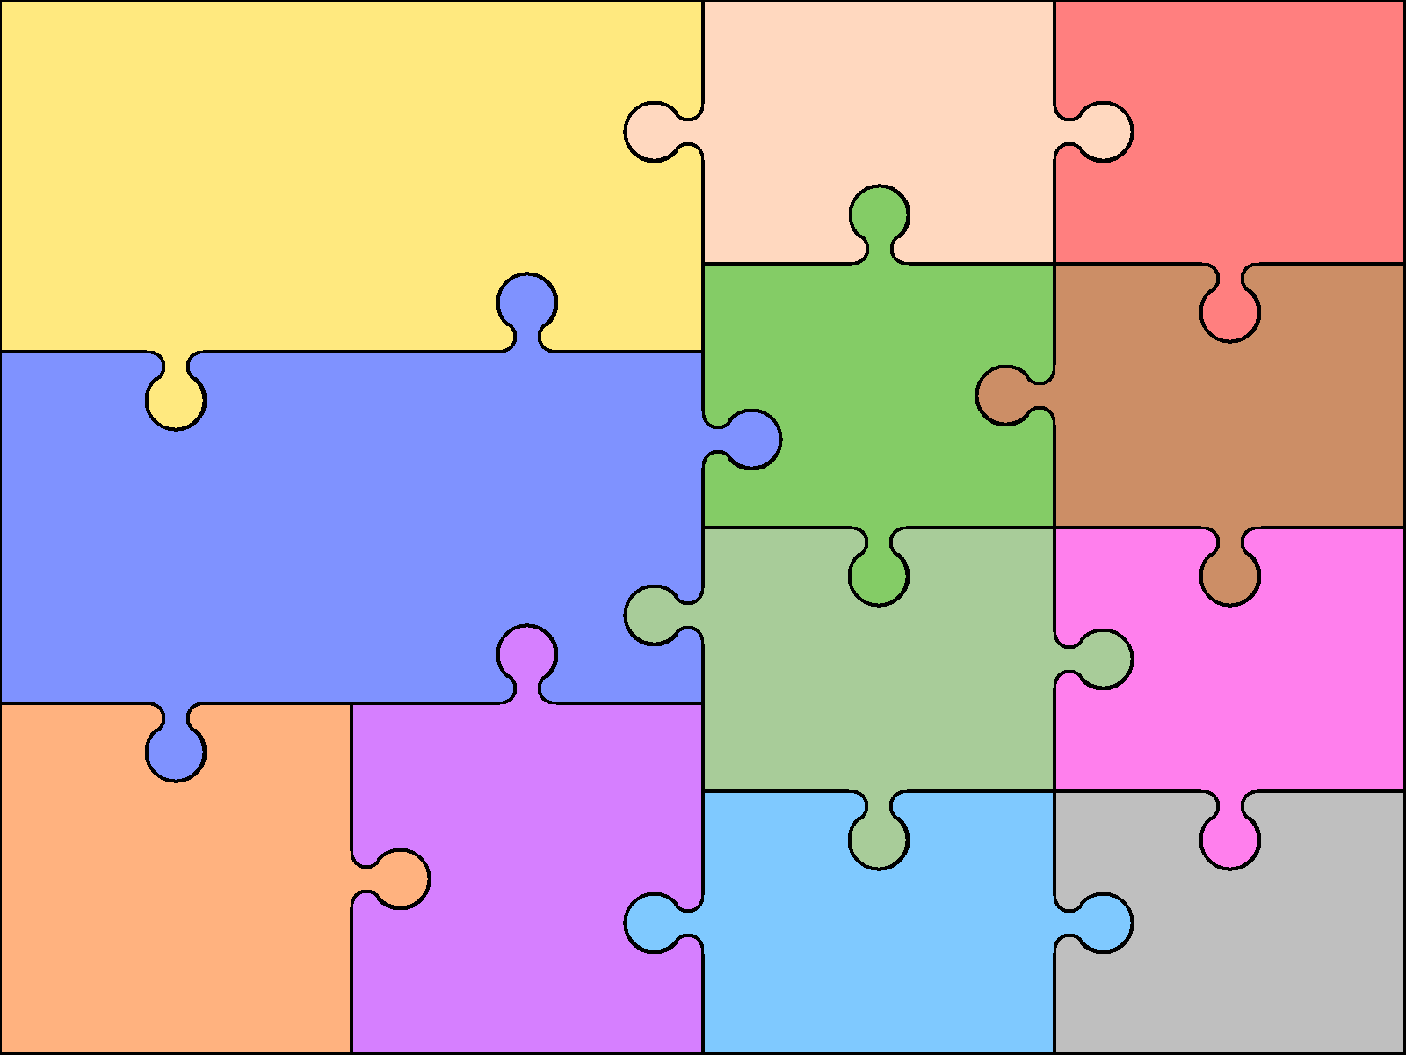  Reading  - apply their growing knowledge of root words, prefixes and suffixes (morphology and etymology), as listed in English appendix 1, both to read aloud and to understand the meaning of new words that they meet  - increasing their familiarity with a wide range of books, including myths, legends and traditional stories, modern fiction, fiction from our literary heritage, and books from other cultures and traditions  - checking that the book makes sense to them, discussing their understanding and exploring the meaning of words in context asking questions to improve their understanding  - drawing inferences such as inferring characters’ feelings, thoughts and motives from their actions, and justifying inferences with evidence | English  COMPOSITION: Planning  Pupils should be taught to plan their writing by:  - identifying the audience for and purpose of the writing, selecting the appropriate form and using other similar writing as models for their own  - noting and developing initial ideas, drawing on reading and research where necessary  - in writing narratives, considering how authors have developed characters and settings in what pupils have read, listened to or seen performed  Draft and Write  - selecting appropriate grammar and vocabulary, understanding how such choices can change and enhance meaning  - in narratives, describing settings, characters and atmosphere and integrating dialogue to convey character and advance the action |  | Evaluate and Edit  - assess the effectiveness of their own and others’ writing  - ensuring the consistent and correct use of tense throughout a piece of writing  Vocabulary, Grammar and Punctuation  - using expanded noun phrases to convey complicated information concisely  - using modal verbs or adverbs to indicate degrees of possibility  - using brackets, dashes or commas to indicate parenthesis  - using a colon to introduce a list  - punctuating bullet points consistently  Spelling:  Year 5 and 6 Word Lists | Art & Design  - Children will be taught to:  - -create sketch books to record their observations and use them to review and revisit ideas  - -improve their mastery of art and design techniques, including drawing, painting and sculpture with a range of materials  - -learn about great artists, architects and designers in history. | Computing  - Use technology safely, respectfully and responsibly; recognise acceptable/unacceptable behaviour; identify a range of ways to report concerns about content and contact.  - Use search technologies effectively, appreciate how results are selected and ranked, and be discerning in evaluating digital content
 |  |  |  | Design & Technology  Design:  - use research and develop design criteria to inform the design of innovative, functional, appealing products that are fit for purpose, aimed at particular individuals or groups  Make:  - select from and use a wider range of tools and equipment to perform practical tasks accurately  - select from and use a wider range of materials and components, including construction materials, textiles and ingredients, according to their functional properties and aesthetic qualities  Technical Knowledge:  - apply their understanding of how to strengthen, stiffen and reinforce more complex structures  - Evaluate:  - evaluate their ideas and products against their own design criteria and consider the views of others to improve their work | Geography  Locational knowledge  - locate the world’s countries, using maps to focus on Europe (including the location of Russia) and North and South America, concentrating on their environmental regions, key physical and human characteristics, countries, and major cities  Geographical skills and fieldwork  - use maps, atlases, globes and digital/computer mapping to locate countries and describe features studied
- identify the value of each digit in numbers given to three decimal places and multiply and divide numbers by 10, 100 and 1000 giving answers up to three decimal places multiply one-digit numbers with up to two decimal places by whole numbers  - use written division methods in cases where the answer has up to two decimal places  - solve problems which require answers to be rounded to specified degrees of accuracy  - describe positions on the full coordinate grid (all four quadrants)  - Draw, reflect and translate simple shapes on the co-ordinate plane | Mathematics  - recall and use equivalences between simple fractions, decimals and percentages, including in different contexts.  - solve problems involving the relative sizes of two quantities where missing values can be found by using integer multiplication and division facts  - solve problems involving the calculation of percentages [for example, of measures, and such as 15% of 360] and the use of percentages for comparison |  | - solve problems involving similar shapes where the scale factor is known or can be found  - solve problems involving unequal sharing and grouping using knowledge of fractions and multiples.  - use simple formulae  - generate and describe linear number sequences  - express missing number problems algebraically
 |  |  |  | Modern Languages  - Speak sentences using familiar vocabulary, phrases and basic language structures. Engage in conversations; ask and answer questions; express opinions and respond to those of others. Write phrases from memory and adapt these to create new sentences, to express ideas clearly. | Music  - play and perform in solo and ensemble contexts, using their voices and playing musical instruments with increasing accuracy, fluency, control and expression  - appreciate and understand a wide range of high-quality live and recorded music drawn from different traditions and from great composers and musicians  - develop an understanding of the history of music.  - Listen with attention to detail and recall sounds with increasing aural memory.
Science  - compare and group together everyday materials on the basis of their properties, including their hardness, solubility, transparency, conductivity (electrical and thermal), and response to magnets  - use knowledge of solids, liquids and gases to decide how mixtures might be separated, including through filtering, sieving and evaporating  - give reasons, based on evidence from comparative and fair tests, for the particular uses of everyday materials, including metals, wood and plastic  - demonstrate that dissolving, mixing and changes of state are reversible changes  - explain that some changes result in the formation of new materials, and that this kind of change is not usually reversible, including changes associated with burning and the action of acid on bicarbonate of soda. |  | History  - know and understand the history of these islands as a coherent, chronological narrative, from the earliest times to the present day: how people’s lives have shaped this nation and how Britain has influenced and been influenced by the wider world.  - understand historical concepts such as continuity and change, cause and consequence, similarity, difference and significance, and use them to make connections, draw contrasts, analyse trends, frame historically-valid questions and create their own structured accounts, including written narratives and analyses
 |  |  |  | Physical Education  - Play competitive games, modified where appropriate [for example, badminton, basketball, cricket, football, hockey, netball, rounders and tennis], and apply basic principles suitable for attacking and defending  - perform dances using a range of movement patterns  - compare their performances with previous ones and demonstrate improvement to achieve their personal best. | Religious Education  - Is anything ever eternal  - We are learning to evaluate different beliefs about eternity and to understand the Christian perspective on this.  PSHE  - Clarify own values and re-evaluate values and beliefs in light of new learning.  - Develop strategies to resolve disputes and conflicts through negotiation and appropriate compromise.  - Learn why and how rules and laws protect everyone are enforced. Why are different rules needed in different situations and how to change rules.  - Use of a range of social skills in context.  - 1a, that the life processes common to humans and other animals includes nutrition, movement, growth and reproduction  - 2f, about the main stages of the human life cycle

