Spring Term 2020 ––What does living happily ever after mean? Reception
Enrichment/Trips
- Forest school sessions
- Mobile Farm – 6th January
- Chinese New Year Dance – 20th January 2:45pm
- Express Tea Party come dressed as your favourite story character – 12th February 2pm

Ways to support at home:
- Phonics – practising set 1 sounds/phonics home learning
- Maths home learning
- Sharing Learning Journeys
- To share a story book with your child every evening.
- You can practise with your child, writing their name.
- You can recognise numbers 0-10 with your children and practise counting.
- Recognising shapes around us

Literacy – Writing
•Links sounds to letters, naming and sounding the letters of the alphabet.
•Uses some clearly identifiable letters to communicate
meaning, representing some sounds correctly and in
sequence.
•Writes own name and other things such as labels,captions
Literacy- Reading
Enjoys rhyming and rhythmic activities.
• Shows awareness of rhyme and alliteration.
• Recognises rhythm in spoken words.
- Hears and says the initial sound in words.
• Can segment the sounds in simple words and blend them together and knows which letters represent some of them.
• Links sounds to letters, naming and sounding the letters of the alphabet.
•Begins to read words and simple sentences.
•Uses vocabulary and forms of speech that are
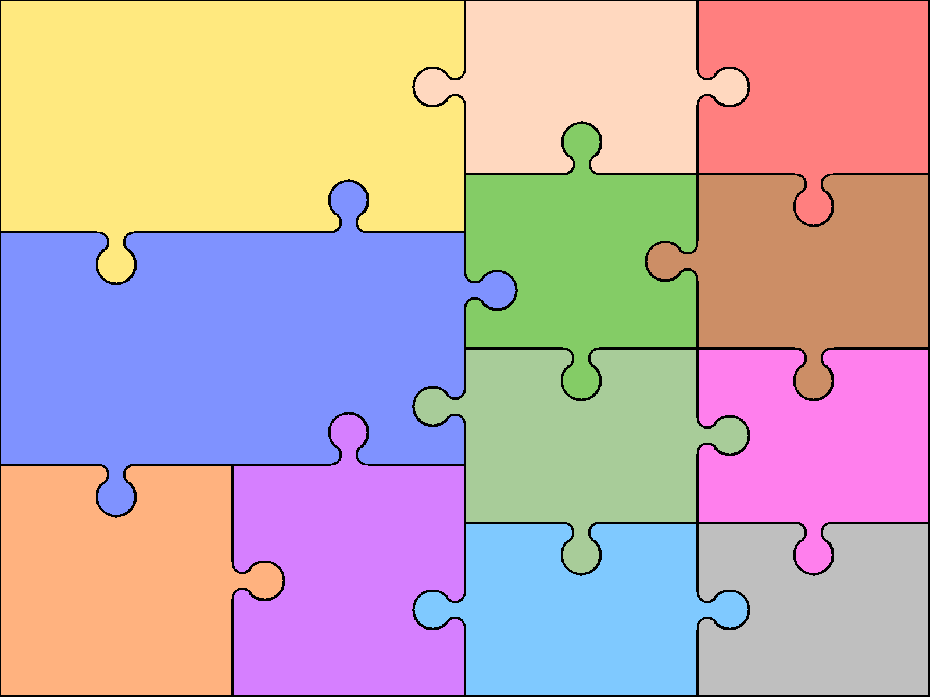  Making Relationships  - Initiates conversation  - Explains own knowledge and understanding, and asks appropriate questions of others. | PSED  Self-Confidence and Self-Awareness  - Can describe self in positive terms and talk about abilities.  - Shows confidence in asking adults for help. |  | Managing Feelings and Behaviours  - Aware of the boundaries set, and of behavioural expectations  in the setting.  - Beginning to be able to negotiate and solve problems without  aggression, e.g. when someone has taken their toy | Physical Development  Moving and Handling  Draws lines and circles using gross motor movements.  • Begins to form recognisable letters  • Holds pencil between thumb and two fingers, no longer using whole-hand grasp.  Health and Self-Care  - Shows some understanding that good practices with regardto exercise, eating, sleeping and hygiene can contribute to good health. | Mathematics - Number  - Number and Place Value – Numbers to 5.  - Addition and Subtraction – Sorting into groups  - Number and Place Value – Comparing Groups, comparing quantities of non-identical objects and identical objects  - Addition and Subtraction – Change within 5 – one more and one less
 |  |  |  | Understanding the world  - Shows an interest in others’ religions and beliefs  - Talk about why things happen and how things work  - Enjoys joining in with family customs and routines.  - Completes a simple programme on a computer | Shape, Space and Measure  - Time – My Day  - Uses positional language.  - Can recognise and use shape names.
Understanding  - Responds to simple instructions, e.g. to get or put away an object.  - Able to follow a story without pictures or props. | Communication, Language and Literacy  Speaking  • Uses talk to connect ideas, explain what is happening and anticipate what might happen next, recall and relive past experiences. • Questions why things happen and gives explanations. Asks e.g. who, what, when, how. • Uses a range of tenses (e.g. play, playing, will play, played). • Uses intonation, rhythm and phrasing to make the meaning clear to others |  | 2  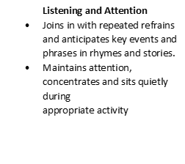
 |  |  |  | Expressive Art and Design  - Explore how different colours are formed  - Explore using texture and pattern to create Artwork  - Enjoys joining in with dancing and ring games | Planned Texts  - Into the Forest  - Goldilocks and the Three Bears  - Three Little Pigs  - Little Red Riding Hood  - Chinese New Year

